**Selecting Your Operating System**

1. Download Windows 11 from [Microsoft's official website](https://www.microsoft.com/software-download/windows11).

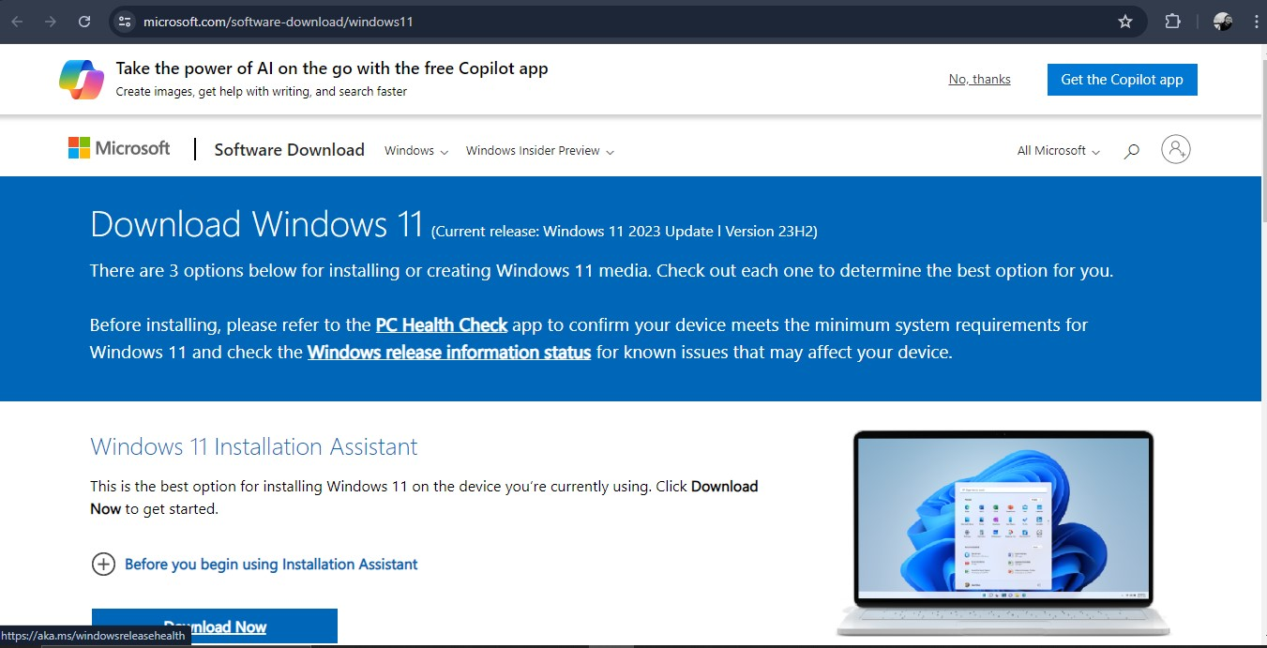

**Installing Visual Studio Code**

1. Download Visual Studio Code from [the official website](https://code.visualstudio.com/Download).

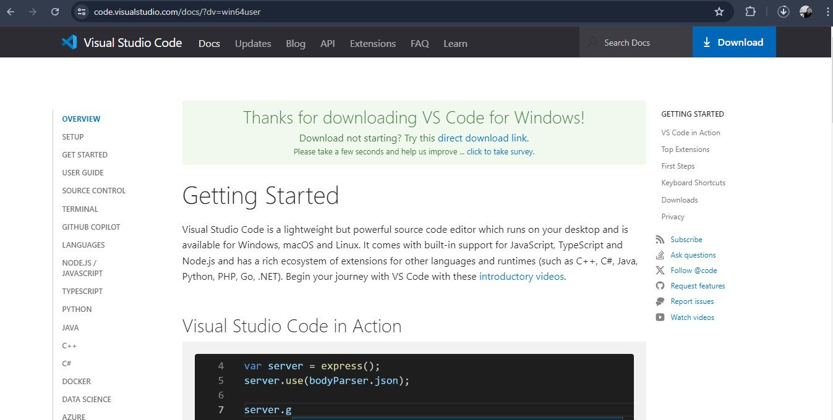

1. Run the installer and follow the setup wizard to install VS Code.

**Setting Up Version Control System**

1. Download and install Git from [the official website](https://git-scm.com/).

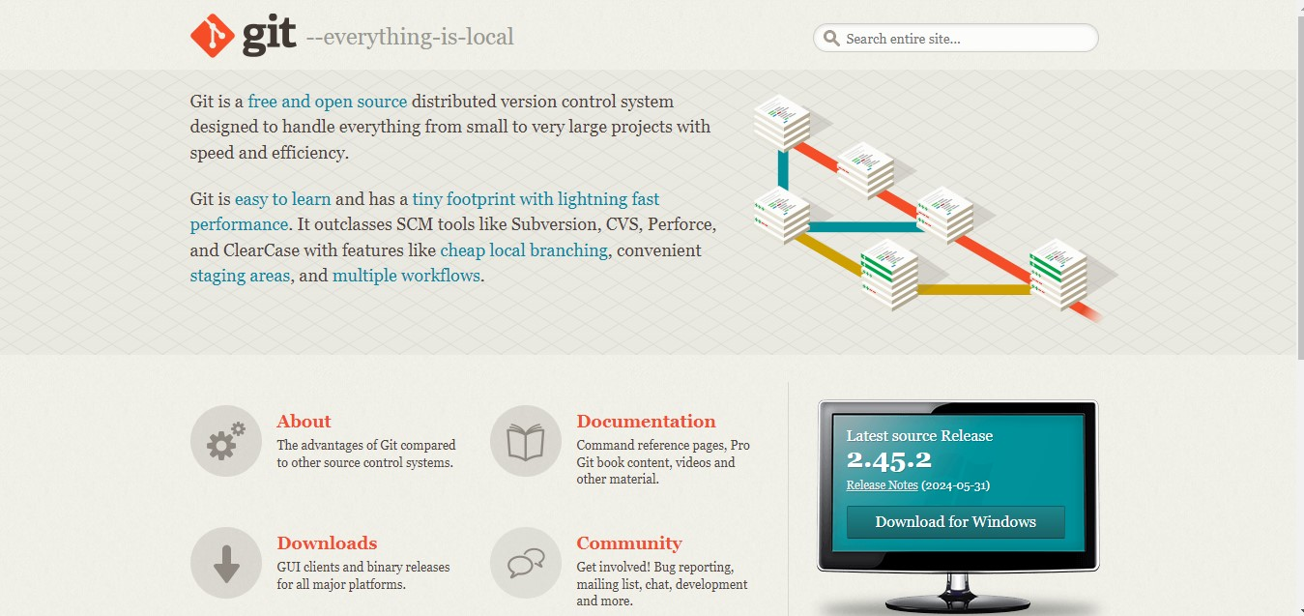

1. Configure Git:

bash

git config --global user.name "hoeseb1"

1. Create a GitHub account at [GitHub](https://github.com).

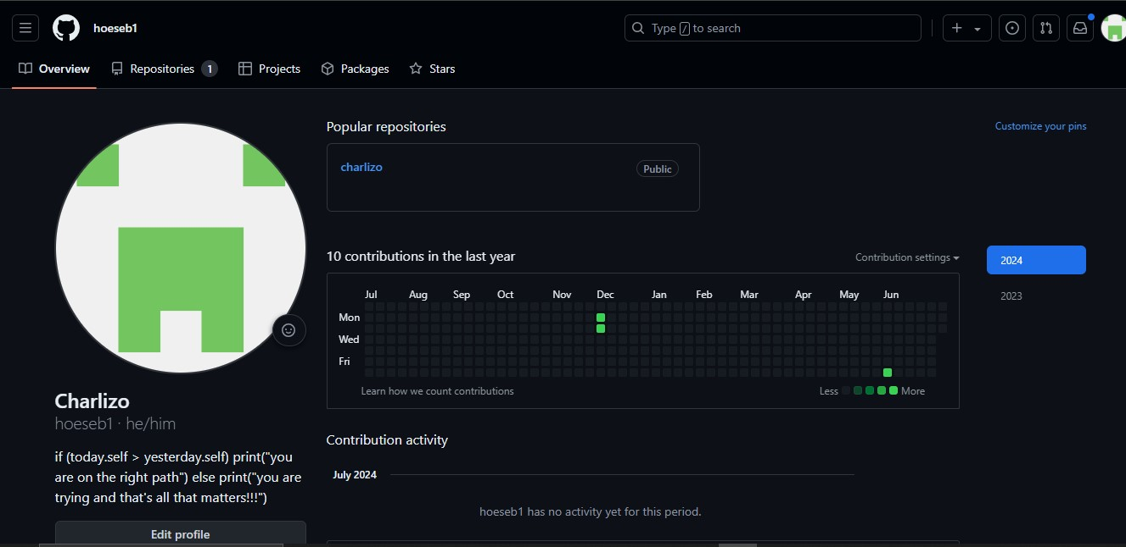

1. Create a new repository on GitHub.
2. Clone the repository:

bash

git clone https://github.com/hoeseb1/your-repository.git

1. Initialize the repository:

bash

Copy code

cd your-repository

echo "# Your Project" >> README.md

git add README.md

git commit -m "Initial commit"

git push origin main

**Installing Python**

1. Download Python from [the official website](https://www.python.org/).

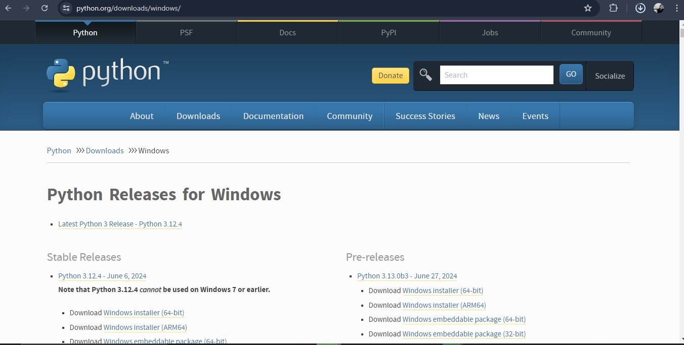

1. Verify the installation:

bash

python --version

**Installing pip**

1. Verify pip installation:

bash

pip --version

**Configuring MySQL**

1. Download MySQL from [the official website](https://dev.mysql.com/downloads/windows/installer/5.7.html).

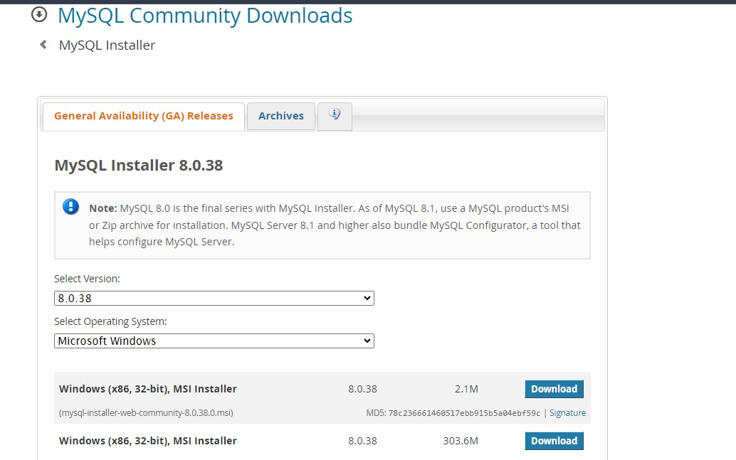

**Setting Up Docker**

1. Download Docker from [the official website](https://www.docker.com/).

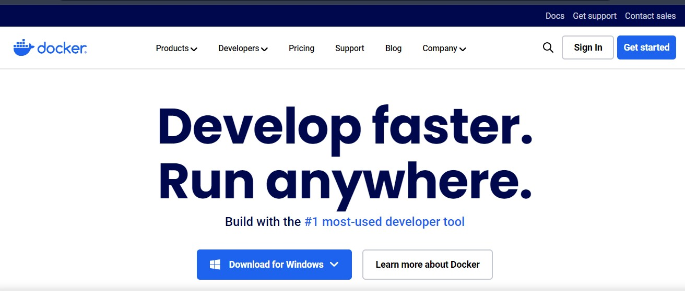

**Exploring Extensions and Plugins in VS Code**

1. Open Visual Studio Code.
2. Go to the Extensions view (Ctrl+Shift+X).
3. Install the following extensions:
   * Python
   * GitLens
   * Prettier - Code formatter
   * Docker

**Reflection**:

During the setup process, I encountered issues with configuring MySQL due to conflicting ports with another database service running on my machine. To resolve this, I changed the default port in the MySQL configuration file. Additionally, setting up Docker required additional configuration for Windows, which I resolved by enabling WSL 2 and following Docker's official installation guide.

By completing these steps and documenting the process, I have a well-rounded understanding of how to set up a developer environment conducive to efficient software development.